the situated wise reasoning scale (swis)

name: ______________________________ date: _______

This hybrid state-level method to assess wise reasoning cues participants to recall an interpersonal conflict that they experienced. To maximize precision in recall, we guide participants to recall a recent episode. Respondents are then guided to reconstruct features of the conflict experience by answering questions about the what, where, when, and how of the situation, including the thoughts and feelings they experi-enced (see ‘situation’ sheet). This reconstruction process aims to increase accuracy and reduce bias in the recall of the experience. Finally, respondents answer questions designed to assess wise reasoning:

The numbers on the right refer to the following responses: 1 = not at all; 3 = somewhat; 5 = very much.

 | statement
1. | I put myself in the other person’s shoes | 1 | 2 | 3 | 4 | 5
2. | tried to communicate with the other person what we might have in common | 1 | 2 | 3 | 4 | 5
3. | made an effort to take the other person’s perspective | 1 | 2 | 3 | 4 | 5
4. | took time to get the other person’s opinions  on the matter before coming to a conclusion | 1 | 2 | 3 | 4 | 5
5. | looked for different solutions as the situation evolved | 1 | 2 | 3 | 4 | 5
6. | considered alternative solutions as the situation evolved | 1 | 2 | 3 | 4 | 5
7. | believed the situation could lead to a number of different outcomes | 1 | 2 | 3 | 4 | 5
8. | thought the situation could unfold in many different ways | 1 | 2 | 3 | 4 | 5
9. | double-checked whether my opinion on the situation might be incorrect | 1 | 2 | 3 | 4 | 5
10. | double-checked whether the other person’s opinions might be correct | 1 | 2 | 3 | 4 | 5
11. | looked for any extraordinary circumstances before forming my opinion | 1 | 2 | 3 | 4 | 5
12. | behaved as if there may be some information to which I did not have access | 1 | 2 | 3 | 4 | 5
13. | tried my best to find a way to accommodate both of us | 1 | 2 | 3 | 4 | 5
14. | though it may not have been possible, I searched for  a solution that could result in both of us being satisfied | 1 | 2 | 3 | 4 | 5
15. | considered first whether a compromise  was possible in resolving the situation | 1 | 2 | 3 | 4 | 5
16. | viewed it as very important that we resolve the situation | 1 | 2 | 3 | 4 | 5
17. | tried to anticipate how the conflict might be resolved | 1 | 2 | 3 | 4 | 5
18. | wondered what I would think if I was somebody else watching the situation | 1 | 2 | 3 | 4 | 5
19. | tried to see the conflict from the point of view of an uninvolved person | 1 | 2 | 3 | 4 | 5
20. | asked myself what other people might think  or feel if they were watching the conflict | 1 | 2 | 3 | 4 | 5
21. | thought about whether an outside person might  have a different opinion from mine about the situation | 1 | 2 | 3 | 4 | 5
subtotals for each column:

total score = ; average score per item =

(see over the page for a typical distribution of SWIS scores in a US population & details of linked research)

questions 1-4: others’ perspectives; 5-8: consideration of change and multiple ways situation may unfold; 9-12: intellectual humility/recognition of limits of knowledge; 13-17: search for a compromise/conflict resolution; 18-21: view of the event through the vantage point of an outsider

Brienza, J. P., et al. (2017). "Wisdom, bias, and balance: Toward a process-sensitive measurement of wisdom-related cognition." Journal of Personality and Social Psychology (online first, September 21).
Philosophers and behavioral scientists refer to wisdom as unbiased reasoning that guides one toward a balance of interests and promotes a good life. However, major instruments developed to test wisdom appear biased, and it is unclear whether they capture balance-related tendencies. We examined whether shifting from global, de-contextualized reports to state-level reports about concrete situations provides a less biased method to assess wise reasoning (e.g., intellectual humility, recognition of uncertainty and change, consideration of the broader context at hand and perspectives of others, integration of these perspectives or compromise), which may be aligned with the notion of balancing interests. Results of a large-scale psychometric investigation (N = 4,463) revealed that the novel Situated WIse Reasoning Scale (SWIS) is reliable and appears independent of psychological biases (attribution bias, bias blind spot, self-deception, and impression management), whereas global wisdom reports are subject to such biases. Moreover, SWIS scores were positively related to indices of living well (e.g., adaptive emotion regulation, mindfulness), and balancing of cooperative and self-protective interests, goals (influence-vs.-adjustment), and causal inferences about conflict (attribution to the self-vs.-other party). In contrast, global wisdom reports were unrelated or negatively related to balance-related measures. Notably, people showed modest within-person consistency in wise reasoning across situations or over time, suggesting that a single-shot measurement may be insufficient for whole understanding of trait-level wisdom. We discuss theoretical and practical implications for research on wisdom, judgment and decision making, well-being, and prosociality.

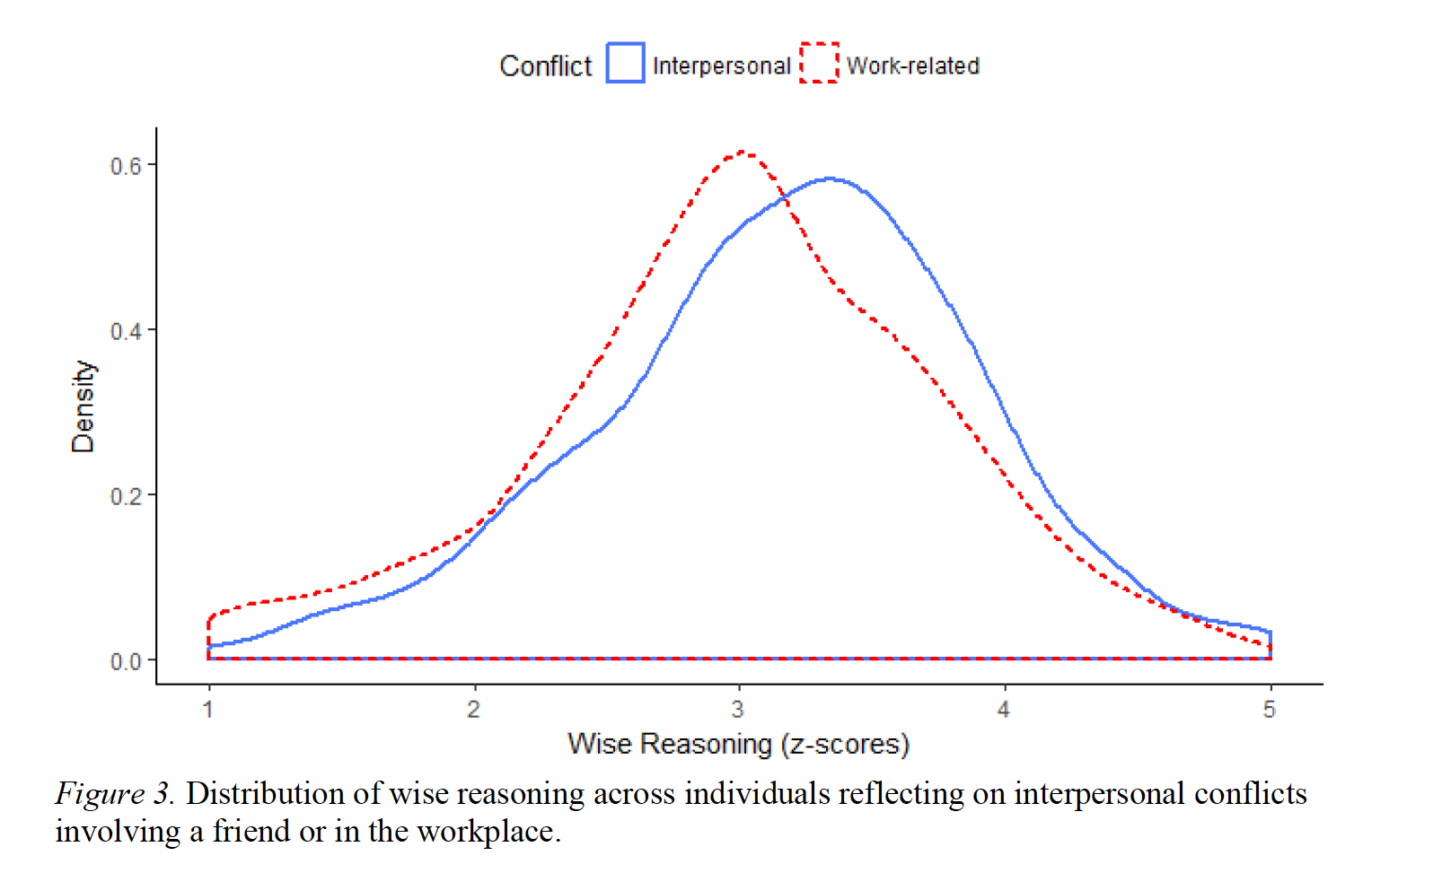

Grossmann, I., et al. (2013). "A route to well-being: Intelligence vs. wise reasoning." Journal of Experimental Psychology: General 142(3): 944-953.
Laypeople and many social scientists assume that superior reasoning abilities lead to greater well-being. However, previous research has been inconclusive. This may be because prior investigators used operationalizations of reasoning that favored analytic as opposed to wise thinking. We assessed wisdom in terms of the degree to which people use various pragmatic schemas to deal with social conflicts. With a random sample of Americans, we found that wise reasoning is associated with greater life satisfaction, less negative affect, better social relationships, less depressive rumination, more positive versus negative words used in speech, and greater longevity. The relationship between wise reasoning and well-being held even when controlling for socioeconomic factors, verbal abilities, and several personality traits. As in prior work, there was no association between intelligence and well-being. Further, wise reasoning mediated age-related differences in well-being, particularly among middle-aged and older adults. Implications for research on reasoning, well-being, and aging are discussed.

